User Guide for
The Mediterranean oceanographic data ACCESS system
MEDACC, Version 12.17

Isaac Gertman¹, Boris Kacenelson¹, Irena Lunin¹, Tal Ozer¹
and Yan Tsehtik²
¹ Israel Marine Data Center (ISRAMAR)
²University of Alberta, Canada

http://isramar.ocean.org.il/Download.asp

I. INTRODUCTION

The MEDACC is a Microsoft “ACCESS” based information system for geochemical and biological data acquired in oceanographic cruises by casting of oceanographic equipment and/or water samplers on open sea stations. The system is able to import data organized in ASCII files according to MEDATLAS format, or Sea-Bird format as well as data organized in EXCEL tables in form similar to generic ODV spreadsheet format (Schlitzer, R., 2001: Ocean-Data-View. An example of the bottle data organized in the appropriate EXCEL table can be found at: http://isramar.ocean.org.il/SESAMEMETA/excel_format_example.xls.
Any portion of selected data can be exported to ASCII files in MEDATLAS format (only cruises where parameter codes are defined by four symbol code) or in the generic ODV spreadsheet format.

Data loaded in the MEDACC can be investigated using a built-in ACCESS query builder as well as using an oceanographic oriented interface which includes following features:
- Data selection according to cruise/cast metadata.
- Plotting of vertical distribution of parameters for a single cast or for a group of casts.
- Plotting of vertical and horizontal sections of parameters.
- Plotting of the distribution of temperature and salinity on an isopycnal surface.
- Plotting TS-diagram for a single cast or a group of casts.

To plot data the MEDACC uses the wide distributed commercial software “SURFER” (Golden Software Inc, http://www.goldensoftware.com) and Microsoft “Excel”, which should be installed priory on the PC.

II. INSTALLATION

Microsoft Office 2000 or higher (Professional or Developer edition) and the commercial Surface Mapping System – SURFER version 7.0 or higher (Golden Software, Inc) should be installed before running the MEDACC setup program.
To install MEDACC, run MEDACC_Setup.exe.
By default, the setup creates two folders:
- C:\MEDACC containing medacc.mdb file
- C:\MEDACCMAPS folders containing accompanying DLLs and templates of the SURFER scripts.
It's possible to change the default paths of the destination folders during the setup process.
The file medacc.mdb contains the system software (excluding DLLs, SURFER scripts and VB Excel codes) as well as data from several cruises as examples. The name “medacc” is default name, which could be changed arbitrary. One can create and use several databases by cloning medacc.mdb and filling by different cruises. All medacc type databases use the same folder C:\MEDACCMAPS as the system folder.
To uninstall the MEDACC it is sufficient to remove the MEDACC and MEDACCMAPS folders as well as all other additional datasets.

III. MEDACC DATA STRUCTURE

The system has five types of tables:
- Seven mandatory metadata tables:
  - Cruise_Titles
  - Cast_Titles
  - Params in cast
  - Data_type_ROSCOP
  - Countries
  - Ships
- One mandatory data table for storing temperature and salinity profiles measured in parallel by CTD or bottle casts (PTS_Data).
- Unlimited number of non mandatory data tables for storing all other parameters. Each such table contains data for one type of parameter only. This parameter has to be defined in vocabulary Vocab_SESAME.
- Ten auxiliary mandatory tables which contain standard vocabularies of metadata codes:
  - Vocabulary_Countries
  - Vocabulary_Ships
  - Vocabulary_Regions
  - Vocabulary_ROSCOP
  - Vocabulary_ArchivingCentres
  - Vocabulary_DataOriginCentres
  - Vocabulary_Flags
  - Vocab_SESAME
  - Vocabulary_Availab
- Three auxiliary mandatory tables which contain information about the system setup and log information about data movement and software changing:
- tblAdminPath
- DATACHANGETRACK
- SOFTDATATRACKING

All mandatory tables are created during the system setup. Non mandatory tables are created during a new data import, when the system encounters a parameter which was not loaded earlier. This parameter should be defined priori in the Vocab_SESAME table.
The SESAME vocabulary code is based on the P091 MEDATLAS Parameter Usage Vocabulary (http://seadatanet.maris2.nl/v_bodc_vocab/welcome.aspx ). In case the parameter was not found in the P091, one can form a new code, which consists from two components:
- parameter code from the controlled BODC Parameter Discovery Vocabulary (P021).
- unit code from the controlled BODC data storage units vocabulary (P061).

Both vocabularies are recommended by SEADATANET (http://www.seadatanet.org) as a standard for oceanographic metadata. For example: “TPHSUGPL” is the code for the parameter: particulate total and organic phosphorus concentrations in the water column expressed as Micrograms per litre. In cases where a parameter or units could not be identified in the BODC Vocabularies by the data provider, a temporary name consisting of the letters “SES” plus an auto number was given through using the SESAME Vocabulary interface (http://isramar.ocean.org.il/SESAMEMETA/param_vocab_search.aspx). In the future these “SESnnn” codes have to be replaced by standard codes once they will be defined in BODC vocabularies.

Below we provide descriptions of main tables. Other tables have an evident structure and any necessary details can be obtained by opening the tables in ACCESS design mode.
Cruise_Titles table contains cruise metadata according to the requirements of MEDATLAS format

Field Name | Data Type | Description
ID_Cruise  MAR  Cruise_Name  Ship_Code  Start_Date  End_Date  Reg  Country_Code  AddLab  ScName  PrName  ArchCode  AvailCode  Comments  Source | AutoNumber  Text  Text  Text  Date/Time  Date/Time  Text  Text  Text  Text  Text  Text  Text  Memo  Memo | Primary key  MEDATLAS reference  Originator cruise name/reference  Ship code via IOC definition  Date of the cruise start  Date of the cruise end  Code of the Mediterranean Region  Source laboratory country code  Address: laboratory, institution, town  Chief scientist full name  Name of the project  Regional archiving center code  Data availability code  Comment from cruise header  Source file name
Table 1: Fields of the Cruise_Titles table containing cruise metadata.

Cast_Titles table contains the metadata for each cast. ID_Cruise field is used for relating the cast with the Cruise_Titles table. ID_Cast field is a primary key in the Cast_Titles and is used as a reference to all related records for the cast in other tables. The geographic coordinates of a cast are stored in Lat and Lon fields as degrees accurate to one-hundredth of a minute. Date and time of a cast are stored in corresponding fields Date_Cast and Time_Cast in the appropriate inner formats of ACCESS

Field Name | Data Type | Description
ID_Cruise  ID_Cast  Date_Cast  Time_Cast  FDT  Lat  FLat  Lon  FLon  Depth  FD  StationName  SourceFileName  RecLines  GPQF  DC_hist  DM_hist  Samples  Comments | Number  AutoNumber  Date/Time  Date/Time  Number  Number  Number  Number  Number  Number  Number  Text  Text  Number  Number  Text  Text  Memo  Memo | Foreign key  Primary key  Quality flag of date and time  Latitude in degrees  Quality flag of latitude  Longitude in degrees  Quality flag of longitude  Bottom depth in meters  Quality flag of depth  Cast identification from source file  Source file name  Number of observation records  Global quality flag for the profile  Data calibration history (method, instr., etc)  Data management history  Particular sea surface samples for the parameter
Table 2: Fields of the Cast_Titles table containing cast metadata.

A number of measured parameters for particular ID_Cast assumes to be constant for each level. The number can be achieved by queering the Parameters table. A missing parameter at any particular level of measurements must be replaced by a dummy value. If a parameter is absent on all levels it is attested in Parameters table (QC_Flag=”no data”). This structure was inherited from the MEDATLAS format. The QC_Flags table can be merged with the Cast_Titles table. However, separation of the tables increases the efficiency of the system.

Parameters table describes the set of oceanographic parameters included in each profile in terms of Vocab_SESAME table. The

Field Name | Data Type | Description
ID_Cast  ParamAbr  ParName  Unit  Def  QC_Flag  AbrMethod | Number  Text  Text  Text  Text  Text  Text | Foreign key  Parameter abbreviator according to GF3 code  Parameter name according to GF3 code  Units of measurements  Parameter format, used for output in MEDATLAS format  Global quality flag for each parameter  Method of data transformation
Table 3: Fields of the Parameters table containing information about a set of oceanographic parameters measured on each cast.

Data_type_ROSCOP table contains a description of the data types which were observed in a cruise in terms defined by the Intergovernmental Oceanographic Commission (IOC) instructions (Cruise Summary Report, http://www.sea-search.net/roscop ). The typical data types are: bottle data, CTD data, thermograph data etc. The QC field contains information about the availability of quality control for the data type in the current database.

Field Name | Data Type | Description
ID_Cruise  ROSCOP  NumProf  QC | Number  Text  Number  Text | IOC/ROSCOPE code of data type  Number of profiles for the data type  The data type quality control presence
Table 4: Fields of the Data_type_ROSCOP table containing the cruise information in terms of the IOC Cruise Summary Report document.

Country and Ship tables contain lists of ships and countries of cruises which are included in the MEDACC. These tables are based on the correspondent vocabularies Vocabulary_Countries and Vocabulary_Ships.

Field Name | Data Type | Description
Country_Code  NAME | Text  Text | IOC country code  Country name
Table 5: Fields of the Country table containing list of countries.

Field Name | Data Type | Description
Ship_Code  Ship_Name | Text  Text | IOC ship code  Ship name
Table 6: Fields of the Ship table containing list of ships.

The following group of tables contains the results of the measurements.
PTS_Data is the mandatory table. In MEDACC is assumed that each cast includes at least temperature and salinity data.

Field Name | Data Type | Description
ID_Cast  PRES  FPRES  TEMP  FTEMP  PSAL  FPSAL | Number  Number  Number  Number  Number  Number  Number | Foreign key  Pressure  Quality control flag of pressure  Temperature  Quality control flag of temperature  Salinity  Quality control flag of salinity
Table 7: The fields of the PTS_Data table containing values of temperature and salinity at certain pressure.

Any other hydrophysical (turbidity, current speed, current direction etc.) or hydrochemical (oxygen, phosphate, nitrate etc.) data are not mandatory. Therefore, tables for new parameters (which are not stored still in the MEDACC) are created during the loading of cruise files in the MEDACC. Loading procedure always checks for the presence of an appropriate non mandatory table. A new table is created when a new parameter appears in the input stream. The name of a new table, as well as the field name of the seawater parameter, is defined by input procedure in accordance with the Vocab_SESAME table. All non mandatory tables have identical structure and each of them contains data regarding one parameter only. This kind of organization of the database does not limited by priori defined list of seawater parameters.

DOXY table is an example of a non mandatory table containing dissolved oxygen concentration data in sea water.

Field Name | Data Type | Description
ID_Cast  PRES  FPRES  DOXY  FDOXY | Number  Number  Number  Number  Number | Foreign key  Pressure  Quality control flag of pressure  Oxygen  Quality control flag of oxygen
Table 8: The table DOXY for storing dissolved oxygen data at certain pressure as an example of non mandatory data table structure.

IV. RELATIONSHIPS between tables

MEDACC structural integrity (Fig.1) is defined by two main relationships descending from Cruise_Titles table via Cast_Titles table to PTS_Table and other data tables (DOXY, NTRA, PHOS etc.).

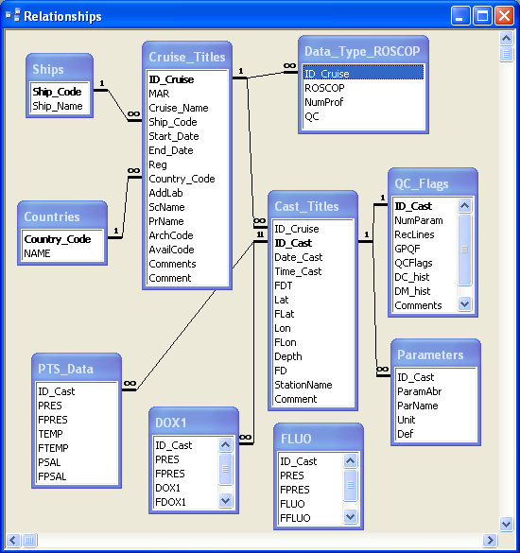

Fig 1. MEDACC relationships.

The type of these relationships is one-to-many. Each record in the Cruise_Titles table is related by primary key ID_Cruise with a group of records in Cast_Titles. Each record in the Cast_Titles table is related by primary key ID_Cast with a group of records in PTS_Table. For casts having any additional parameters (other than temperature and salinity), the corresponding record in the Cast_Titles table could have additional relations with the corresponding records in additional data tables. Relations between Cast_Titles and PTS_Data tables are fixed relations and used for cascading deletion of cruises. Relations between Cast_Titles and other data tables are established temporary only by a cruise deletion procedure. These feature allows to avoid constrains which are connected with limited number of defined table relations in ACCESS.
List of different type of observations which were used in a cruise can be retrieved from Data_Type_ROSCOP table using relations with the Cruise_Titles tables via primary key ID_Cruise. Information related to a cruise is stored also in tables Ships and Countries.
List of measured parameters for each cast can be retrieved from the Parameters table where each cast has a number of corresponding records (with the same ID_Cast) - one record for every observed parameter.
The Cast_Titles and QC_Flags tables are related by a one-to-one relationship. As mentioned above, these two tables could be merged in a unique table, but they have been separated to simplify their usage.
V. OPERATION WITH MEDACC system

MEDACC manager form appears on the system startup. This form has tree buttons to choose one of three form of activity: investigation of data by means of the system oceanographic interface, data administration by means oceanographic oriented facilities, investigation or management of data by means of ACCESS built-in facilities.

1. Data administration facilities

Oceanographic oriented data administration facilities include actions connected with:
- import and export of new data;
- deletion of data from database;
- derivation of new parameters from already existing data;
- establishing relations between system vocabulary of parameters (Vocab_SESAME) and standard BODC vocabularies;
- cleaning of MEDACC system folders from a temporary files generated during data investigation.

Administration facilities are operated by loading corresponding forms and definition of form controls.

Import MAF_Data form allows import a new oceanographic data formatted in MEDATLAS format. The data can be organized in a series files containing a series of cruises. The current version of MEDACC system does not allow duplication of cruse names. Activating of the Allowing duplication of Cruse Names control does not cancel this limitation, but leads to extending of the duplicated name by suffix ^N, where N is the number of the cruise name repetition. The control Prevent Error Messages serves to prevent warning messages about problems which are encountered during the data export, but all warnings can be found in the log file located in the some folder where the imported data is located. The control Replace ROSCOP Code D90 with H13
is useful during importing ARGO floats data, which have wrong ROSCOP code D90.

Export as MAF Data form allows export cruise data to a text file in MEDATLAS format.

Import SeaBird_Data form allows import data organized in ASCII files in the Sea-Bird *.cnv format. This form includes tools to establish correspondence between the Sea-Bird format metadata names and inner MEDACC metadata names as well as between Sea-Bird format parameter identifiers and MEDACC parameter identifiers defined in Vocab_SESAME table. The import configuration for particular data set can be stored in a configuration file and loaded again during following import session.

Import Exel form allows import data organized in EXCEL spreadsheet according to requirements of ODV Generic format. All included controls defining the export process are similar to controls in the Import SeaBird_Data form

Export as ODV Generic form allows export data to a text file in generic Ocean Data View (ODV) format. The form is started with MEDACC selection form, which is explained in the next chapter.

Delete from DB form allows deleting a single cruise or group of cruises from the MEADACC. After deleting a data from the MEDACC it is recommended to run the built-in ACCESS procedure
Tools|Database Utilities|Compact and Repair Database….

Derive Data form allows derivation of additional parameter from preliminary selected data. The destination parameters can defined and writing the derived data in parameters tables.

Cleanup Temporary Files button allows removing of temporary files created during MEDACC database sessions from the following folders:
\MEDACCMAPC\ MAFout
\MEDACCMAPC\MapBuilder
\MEDACCMAPC\ODVout
\MEDACCMAPC\ParOnBuilder
\MEDACCMAPC\SectBuilder
\MEDACCMAPC\VertDistr

The DATACHANGETRACK table contains log records about loading and deleting cruises.
The tblAdminPath table contains full paths to the MEDACCMAPS folder. The table is filled during the MEDACC setup process, but can be edited manually.
The SOFTDATATRACKING table contains information about the MEDACC software development.

2. Oceanographic oriented graphic interface

Pressing Oceanographic Interface button on MEDACC manager form brings Space and Time Selection form (Fig 2). When the necessary data will be selected a user can continue to build an oceanographic presentation of the data (map, section, vertical profile, TS diagram).
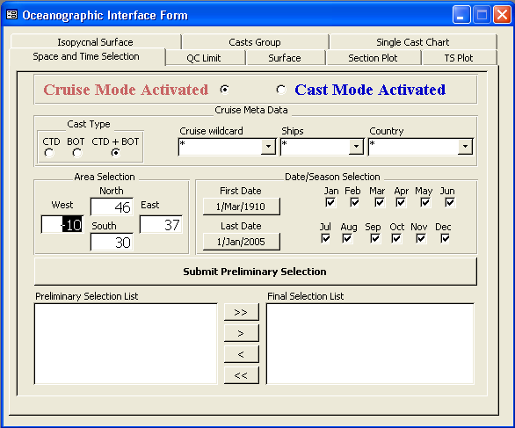
Fig. 2. Controls for data selection on the Oceanographic Interface form.

There are two modes of the data selection: Cruise mode and Casts mode. The Cruise mode allows data selection according to names of cruises. The Cast mode allows more detailed data selection according to station names.
The first result of selection is obtained by pressing Submit Preliminary Selection button. The Preliminary Selection List is appeared in the left window, from which the Final Selection List should be extracted.
In addition to Space and Time Selection controls, additional selection criterions can be defined in the QC Limit form. Those based on data quality flags stored in data tables (PTS_Data, DOXY etc.). Three variants of selection according to quality flags can be activated:
1 - Exclude all data flagged as BAD data.
2 - Include only data flagged as correct.
3 – Include all data.

When some list of cruises or casts will be defined in the Final Selection List window, a user can move to the following forms:
Surface form to create a map with casts position and/or distribution of the selected parameter on the defined water pressure level.
Section Plot form to create a vertical section of the selected parameter.
TS Plot form to plot a classical TS diagram for a single cast or a group of casts.
Isopycnal Surface form to create a map with casts and the selected parameter distribution on the defined isopycnal surface.
Single Cast Chart form to draw a vertical profile of any oceanographic parameters.
Casts Group form to draw composite vertical profiles of several casts.

Plotting of surfaces, sections and TS charts is carried out by appropriate ACCESS VBA procedure, which contains following common steps:
  - Rebuilding the appropriate “SURFER” script file, using a template from MEDACCMAPS folder and output the work script to a work folder.
  - Output the selected data in appropriate ASCII format to the work folder.
  - Launch the “SURFER” Scripter32 to create the chart in the work folder.
Group vertical profiles are plotted by means of EXCEL worksheet template VDGraph Template.xls containing VBE code. The EXCEL template worksheet is copied in a work folder, loaded by selected data and vertical profiles are built inside the worksheet.
Single cast charts are built by ACCESS built-in graphical facilities.

